**Chapter 2: Thermal Transformations**

**All Lectures Uploaded on YouTube:** [**https://tinyurl.com/fkm10-physics**](https://tinyurl.com/fkm10-physics)



# 11.1 Kinetic Theory of Matter

The **Kinetic Theory of Matter** states that:

*All matter is made up of tiny particles (atoms or molecules) that are in constant motion. The energy and movement of these particles determine the state (solid, liquid, or gas) and properties of the substance.*

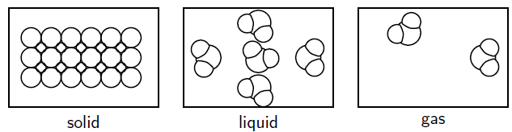

Matter exists in three states: Solid, Liquid, Gas.

• **Solids:** Have fixed shape and volume; particles are closely packed and vibrate about fixed positions.

• **Liquids:** Have fixed volume but no fixed shape; particles slide over each other with less force of attraction.

• **Gases**: Have neither fixed shape nor volume; particles move randomly with negligible force of attraction.

The theory also explains that:

* The temperature of a substance is related to the average kinetic energy of its particles.
* Changes of state (melting, boiling, condensation, etc.) occur because the kinetic energy of particles changes with heat transfer

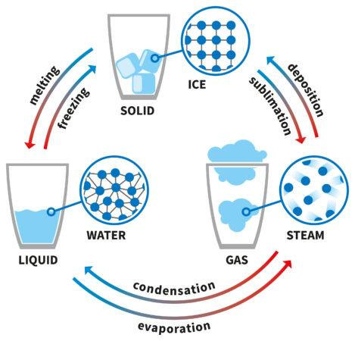

## Phase Changes

• Solid → Liquid: Melting  
• Liquid → Solid: Freezing  
• Liquid → Gas: Evaporation/Boiling  
• Gas → Liquid: Condensation  
• Solid → Gas: Sublimation  
• Gas → Solid: Deposition

# 11.2 Thermal Expansion

When materials are heated, their particles vibrate faster and move apart, causing expansion.

Thermal expansion means "increase in size of matter on heating".

## Expansion in Solids

• **Linear Expansion:** Increase in length of a solid due to heating.

Formula: ΔL = α L₀ ΔT

Where: ΔL = Change in length, L₀ = Original length, ΔT = Temperature change, α = Coefficient of Linear Expansion

• The coefficient of linear expansion is the fractional change in length per degree change in temperature.

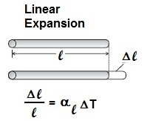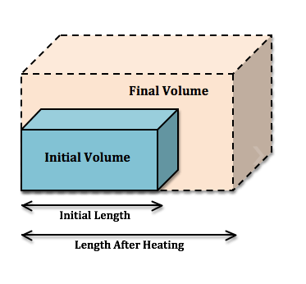

## Volumetric Expansion of Solids

Volume thermal expansion of solids is an increase in volume of substance on heating.

• Volume expansion formula: ΔV = γ V₀ ΔT

Where: γ is the coefficient of volumetric expansion.

| **COEFFICIENTS OF VOLUMETRIC THERMAL EXPANSION** | |
| --- | --- |
| **Material** | **Value of (K-1)** |
| Methanol | 113 x 10-5 |
| Glycerin | 49 x 10-5 |
| Mercury | 18 x 10-5 |
| Turpentine | 90 x 10-5 |
| Acetone | 132 x 10-5 |

## Expansion in Liquids

• Liquids expand more than solids.

• **Linear thermal expansion:** The coefficient of linear thermal expansion is the fractional change in length per kelvin change in temperature.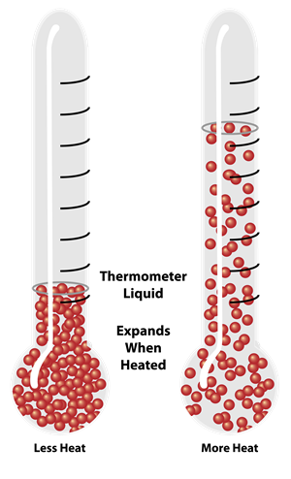

• **Volumetric expansion:** Coefficient of volume thermal expansion is the fractional change in volume per kelvin change in temperature. *Real volume* expansion is thermal expansion in volume of liquid when it is heated directly. *Apparent volume* expansion is thermal expansion of volume of liquid in a container without considering the expansion of its container.

• **Real expansion:** Actual increase in volume of the liquid.

• **Apparent expansion:** Observed increase in volume when heated in a container (due to container expansion).

Formula: γa = γr – γc

Where: γa = Apparent coefficient, γr = Real coefficient, γc = Container coefficient

## Applications and Consequences of Thermal Expansion

• Gaps left between railway tracks to prevent buckling.  
• Thermometers (Mercury and Alcohol Thermometers).  
• Overhead wires sag in summer and contract in winter.  
• Expansion joints in bridges.  
• Bimetallic strips in thermometers and thermostats. (Bimetallic Strips consist of two thin strips of different metals joined together which bend on heating.)

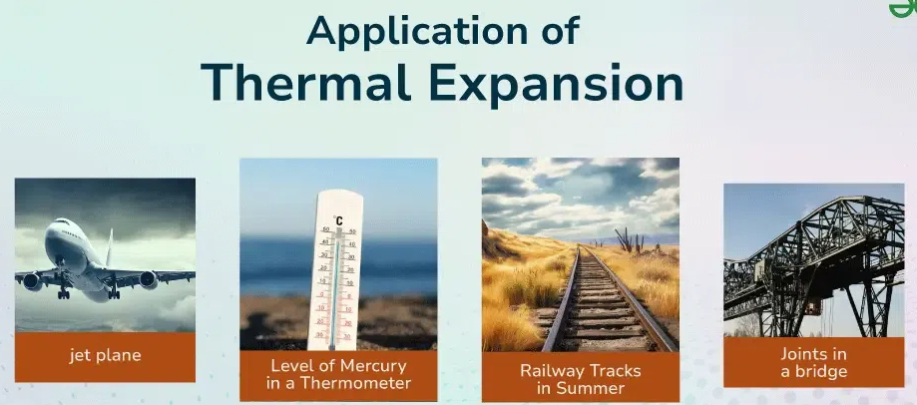

# Evaporation

• The process by which molecules escape from the liquid surface at any temperature below boiling point. Evaporation is the phenomenon of conversion liquid into vapours at any temperature.

**Causes:** High-energy molecules escape from the surface.  
**Cooling Effect:** Evaporation lowers the temperature of the remaining liquid.

**Factors affecting rate:**  
• Surface area  
• Temperature  
• Wind speed  
• Humidity

## Evaporation vs Boiling

• **Evaporation:** Takes place at any temperature, only at the surface, is a slow process.  
**• Boiling:** Takes place at fixed temperature (boiling point), throughout the liquid, rapid process.

## Applications and Consequences of Evaporation

• The cooling effect of sweat.  
• Quick drying of clothes on windy days.  
• Cooling of water in earthen pots.  
• Refrigeration and cooling devices. (Refrigerant is a material used to produce cooling in a refrigerator that absorbs and releases heat by cycling between liquid and gaseous state.)

# Latent Heat

• Heat required to change the state of a unit mass of a substance without change in temperature.

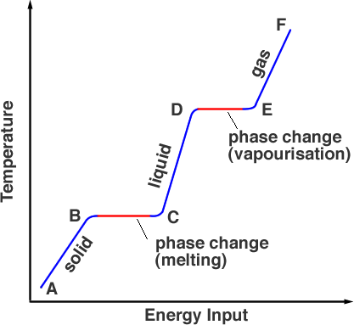

• **Latent heat of fusion:** Heat required to change solid into liquid at constant temperature.

• **Latent heat of vaporization:** Heat required to change liquid into gas at constant temperature.

# Pressure exerted by Gas Particles

• Pressure is due to collisions of gas molecules with container walls.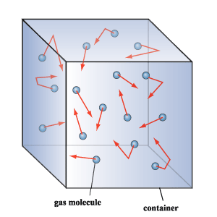

• Pressure is Force on unit area on an object perpendicularly.

• Pressure of Gas is the measure of force exerted by the gas particles on the unit area of the walls of the container perpendicularly.

**Formula**: $P=\frac{F}{A}$, where

P = Pressure, F = Force, A = Area.

# Superconductivity

• The property of certain materials to conduct electricity with zero resistance below a critical temperature.

• Superconductors are those materials through which current flows without resistance.

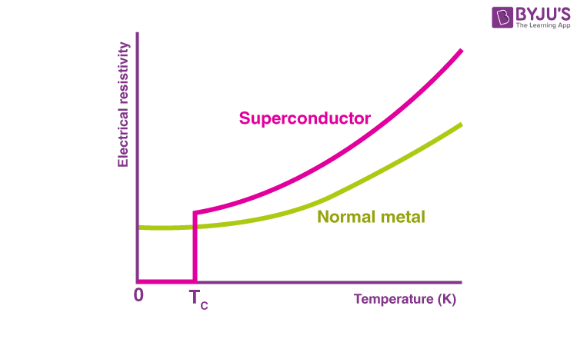

| **CRITICAL TEMPERATURES OF SOME SUBSTANCES** | |
| --- | --- |
| **Substance** | **Critical Temperature (K)** |
| Mercury (Sb) | 4.2 K |
| Aluminum (Al) | 1.18 K |
| Tin (Sn) | 3.72 K |
| Lead (Pb) | 7.2 K |
| Yttrium Barium Copper Oxide (YBCO) | 92 K |

